**Enjoy Your Flight**

In the 1995 movie *French Kiss,* Meg Ryan’s character, Kate, is obsessed with going to Paris, but is simultaneously terrified of being on a plane and a catastrophe occurring. She wants to go to Paris so much she attempts to get over her fear of flying by undergoing therapy via flights in a simulator - which unfortunately also trigger her flight-related panic attacks and is unsuccessful. Kate’s paranoia stems from her habit of watching the evening news and 60 Minutes specials religiously. Sadly, these seem to mostly focus on everything horrible that can happen in any situation. When her fiancé falls in love while in Paris without her and decides to stay in France, Kate forces herself on a plane to go win him back. The passenger next to her notices her panic and tries to help calm her down. He asks how she gets around if not by flying to which she responds “I get around as nature intended: in a car.”

Kate is not alone in her fear of flying and her preference for car travel. According to the U.S. Department of Transportation, over 95% of trips less than 500 miles long are undertaken by personal vehicles and cars remain a large percentage in longer trips as well though air travel gains as trips get longer (Fig. 1) – perhaps due to the inability to drive to the destination as in Kate’s case from Canada to France.

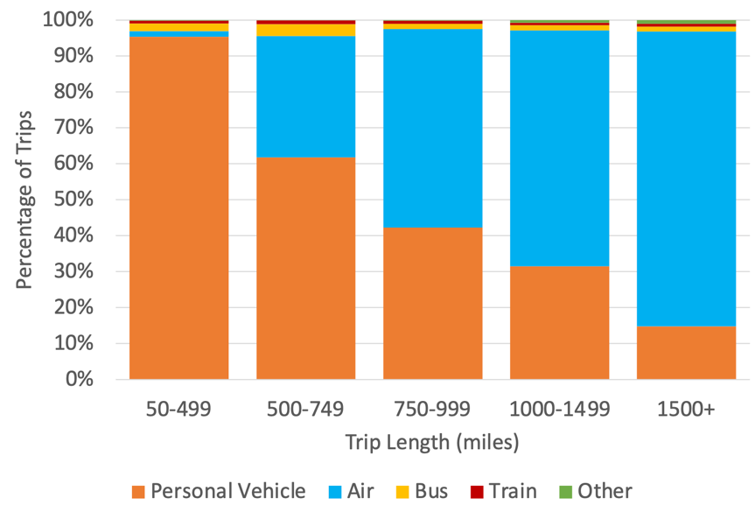

Figure . Breakdown of Mode of Transportation by Trip Length

Despite, or perhaps because of, the preference for car travel, the U.S. National Highway Traffic Safety Administration (NHTSA) records more than 30,000 fatal car accidents each year in the United States. This number doesn’t even include the regular fender benders we pass by every day on our daily commute. The more individual components you have in play, the more likely individuals will try to defy the laws of physics and try to occupy the same space at the same time with disastrous results. The results usually don’t make headlines or a 60 Minutes special for Kate to watch unless the crash results in a multi-car pileup or closes a major highway.

On the flipside, any time something happens with an airplane, the incident tends to make headlines. Many of us can remember where we were when the at least one of the headlines in Figure 2 occurred:

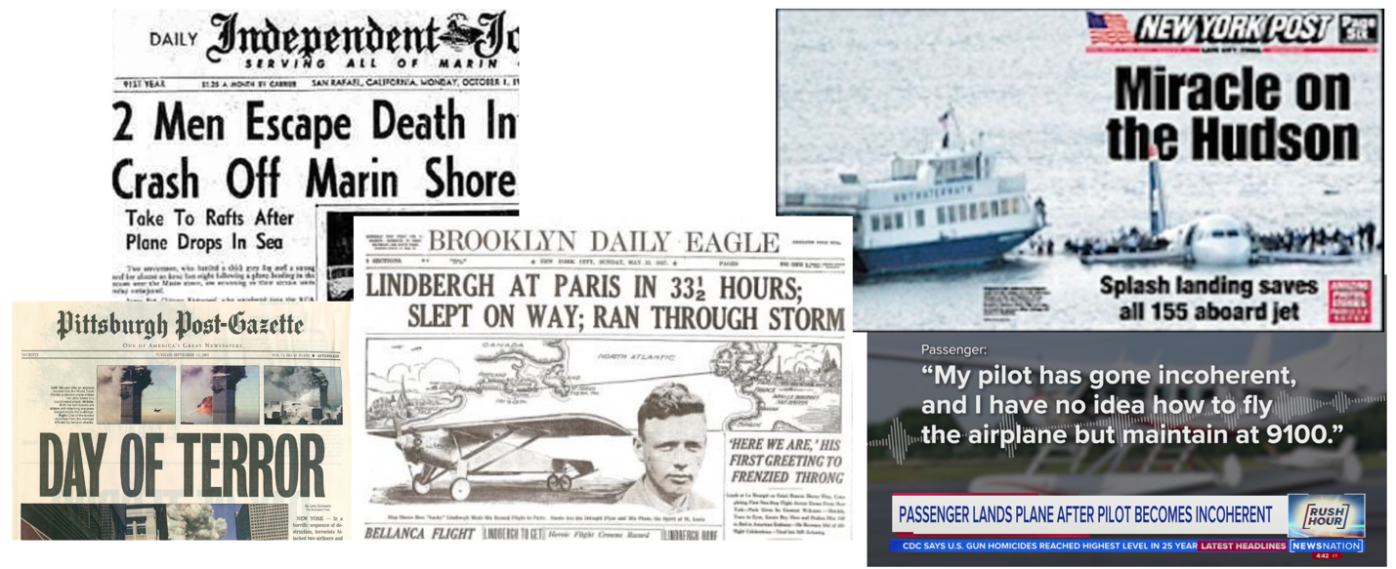

Figure . Sample Headlines Involving Aircraft

At its peak around 1950, only 65 airline accidents were recorded in a single year and that number has significantly dropped down to roughly 10 accidents a year in more recent years (Fig. 3). That drop of 83% means current flying is more safe now than it has ever been before. Most airline incidents occur during training, test flights, or sightseeing excursions not main passenger routes. This is probably due to decreased skill level of the pilots or preparation. These accidents typically involve only a small number of people. Most heavily traveled routes typically had a total of fewer than 2 incidents each.

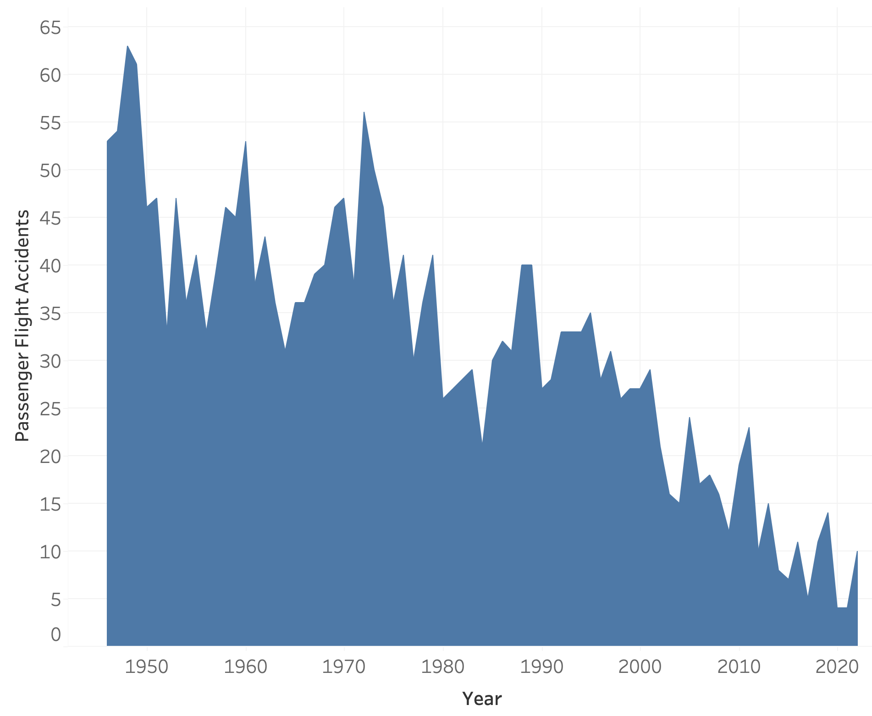

Figure . Counts of Passenger Flight Accidents Per Year Over Time.

Even within the overall accidents, less than 20% result in fatalities. For example, the “Miracle on the Hudson” news headline spotlighted an accident, but one in which there were no fatalities (except for the poor Canada geese which got sucked into the engines), just some injuries and cases of hypothermia due to the water landing in the cold.

At the same time accidents are decreasing, the number of flights annually has increased more than 400% - that’s more than four times the flights in 2020 as there was in the 1970’s (Fig. 4). This means that the likelihood of you as an individual passenger being involved in an airline accident has decreased from roughly 0.00007% to 0.0000003%. For comparison, the approximate risk of being in the airline accident dropped from the risk of being struck by lightning[1](https://www.britannica.com/question/What-are-the-chances-of-being-struck-by-lightning#:~:text=The%20odds%20that%20one%20will,struck%20by%20lightning%20every%20year.) (0.00007%) to the risk of being bitten by a shark[2](https://www.floridamuseum.ufl.edu/discover-fish/sharks/shark-attack-faq/#:~:text=What%20are%20the%20chances%20of,than%20are%20bitten%20by%20sharks.) (0.0000003%).

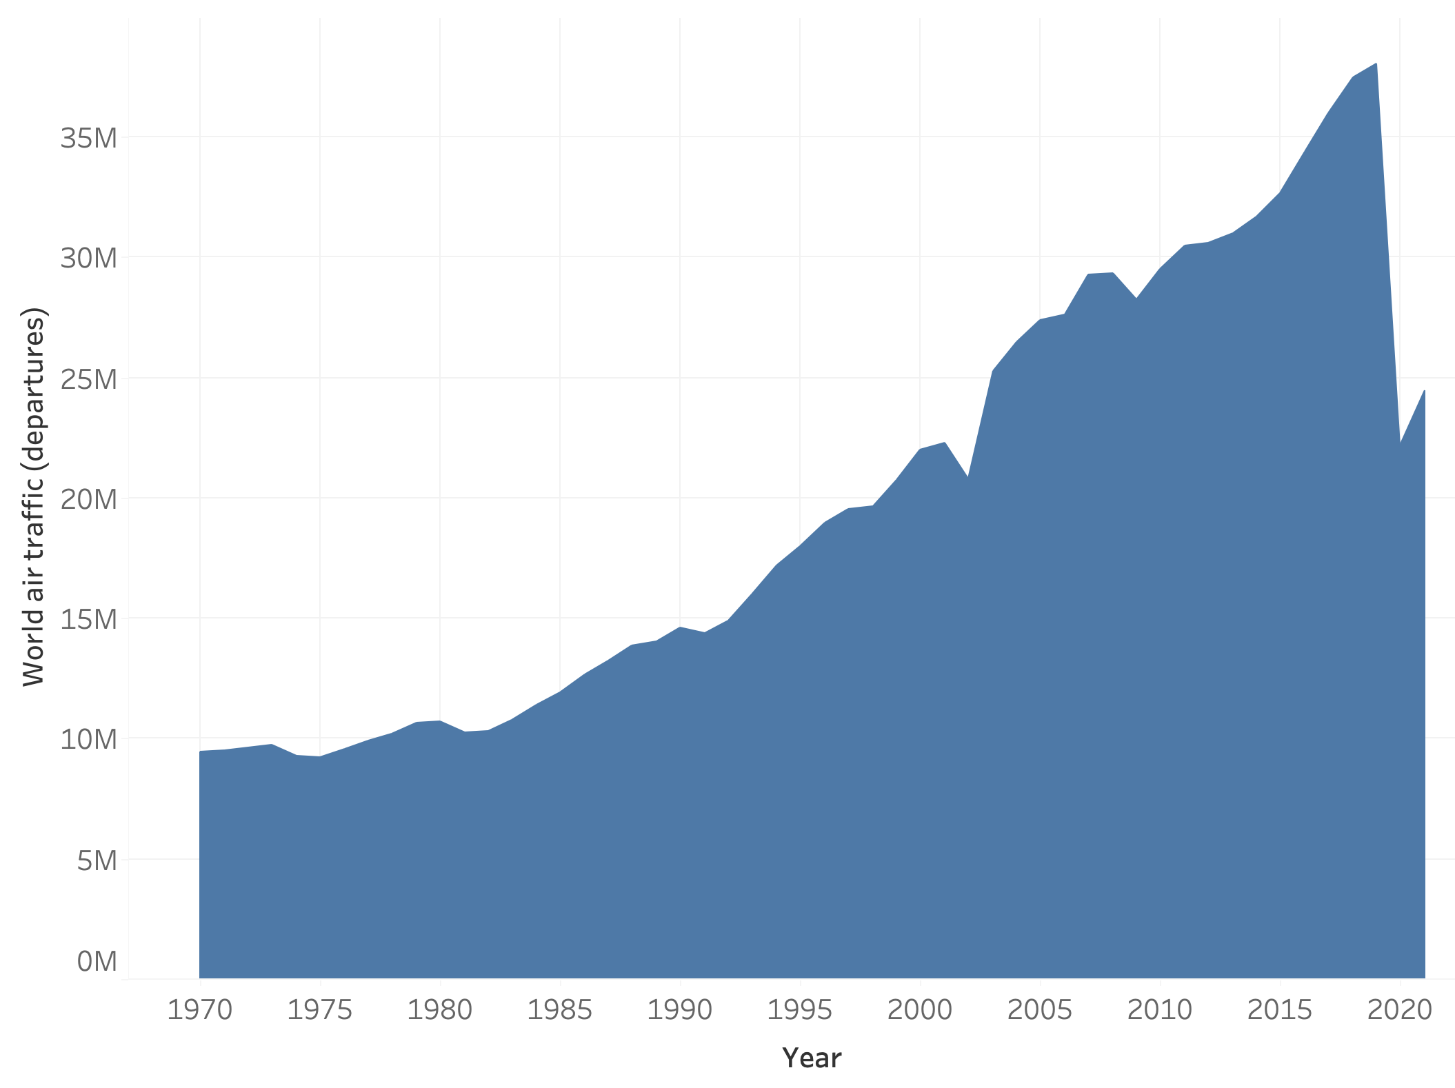

Figure . Number of Flights Annually Over Time

Because airline accidents are so rare and more people are usually involved in the incident, the event tends to be more sensational and draws the attention of the media. Everyone wants to know what happened and how it happened. A similar accident on the road would most like end up being “Driver [A] lost control of their car due to [reason X] and started a chain reaction that caused [Y number of] cars to become involved in the crash”. We have essentially become desensitized to car accidents since we come across them almost daily. A headline covering this car crash will not garner much attention and thus the media tends to not focus on events like that.

If we compare the number of fatalities from airplanes to the number of fatal car crashes just here in the US, we see the number is vastly dwarfed by the massive amounts of people killed each year by being on the road (Fig. 5); even assuming only one fatality occurred in each car crash which is often not the case. The number of car fatalities does not appear to be getting much better and yet we are still determined to drive everywhere.

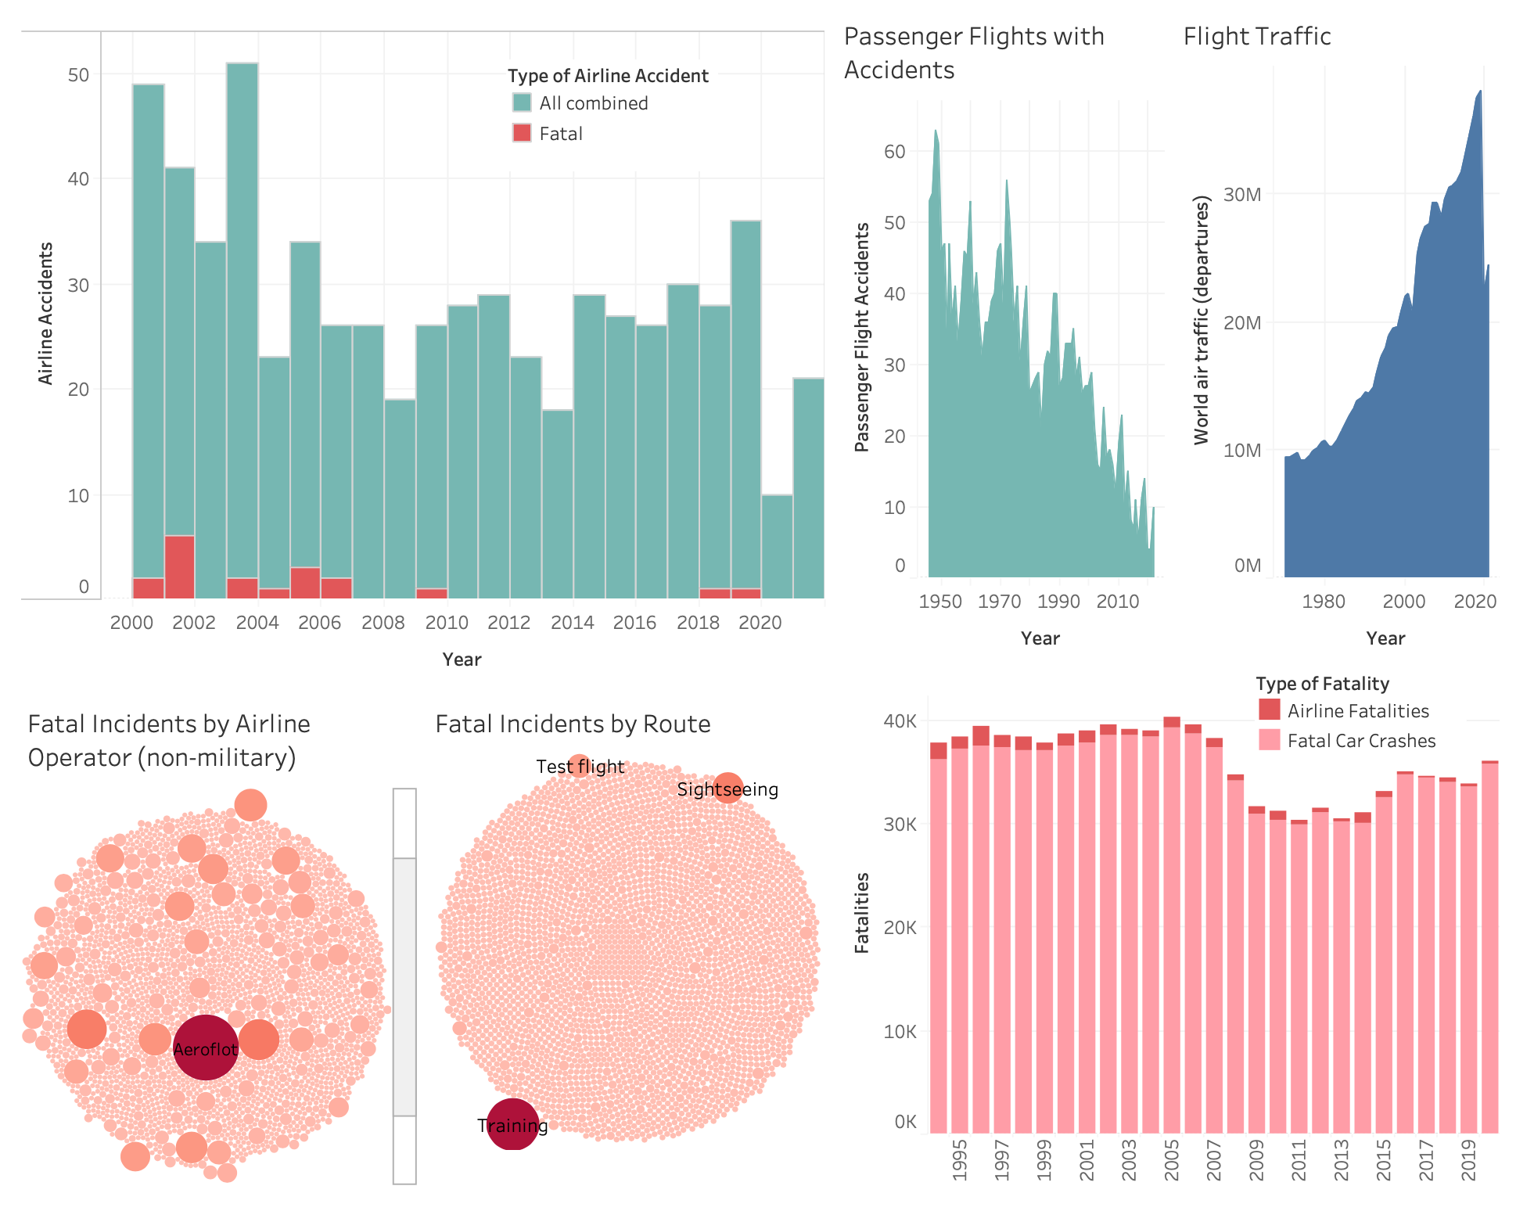

Figure . Comparison of Fatal Incidents Between Cars and Aircraft.

There are many reasons why many people prefer to drive their own vehicle when traveling. You have flexibility in when and where you go because you are in control in a private space you are familiar with. When you get to your destination, you still have your own mode of transportation and don’t have to rent a strange car which can save on costs.

However, like mentioned before, there are certain destinations you can’t drive to unless your car can also drive on water and make it across the ocean without stopping for gas along the way. Air travel is often a more efficient use of time and can sometimes be cheaper in the long run. It is also vastly safer than being on the road since the number of moving parts is greatly reduced in addition to modern safety measures and computer redundancies.

Overall, you most likely do not live your life unduly worried about getting hit by lightning or being bitten by a shark, you take precautions. As with anything in life, and with any form of travel, there is of course some risk, but you take precautions and be prepared. For air travel, this means booking your trip through a reputable air travel company, paying attention to the flight attendant’s safety briefing at the beginning of the flight so you know what to do if the unlikely does happen, and always following crew member instructions as their job is to get you to your destination safely and comfortably.

Kate made it safely to Paris and back and, despite many comical near misses for the audience, FINALLY saw the Eiffel Tower. Enjoy your flight and start imagining what new adventures await you at your destination. Safe travels!

***Data Sources:***

* Accidents numbers from Accidents and Fatalities Per Year (<https://docs.google.com/spreadsheets/d/1SDp7p1y6m7N5xD5_fpOkYOrJvd68V7iy6etXy2cetb8/edit#gid=1448957446>).
* Airplane Crashes 1908-2009 (<https://data.world/hhaveliw/airplane-crashes-1908-2009>)
* NHTSA Summary of Motor Vehicle Traffic Crashes (<https://www-fars.nhtsa.dot.gov/Main/index.aspx>)
* Safety Record of U.S. Air Carriers (<https://www.airlines.org/dataset/safety-record-of-u-s-air-carriers/>)
* Shark Bite Risk from <https://www.floridamuseum.ufl.edu/discover-fish/sharks/shark-attack-faq/#:~:text=What%20are%20the%20chances%20of,than%20are%20bitten%20by%20sharks>.
* Lightning Strike Risk from <https://www.britannica.com/question/What-are-the-chances-of-being-struck-by-lightning#:~:text=The%20odds%20that%20one%20will,struck%20by%20lightning%20every%20year>.

**Blog Post Discussion:**

My blog post is much more informal than the previous audiences and attempts to be much less technical. I am assuming the audience is an average person worried about flying and looking for more information. The graphs are given as a supplemental and are not necessary to be able to understand the article as the main points are already included in the text.

I start out my post by referencing a movie character who also experiences a fear of flying but is able to overcome it with her own will power. This pop culture reference, though perhaps slightly dated at this point, helps draw in the reader through narrative and also shows that others share the reader’s potential apprehension. I use the character’s own declaration that she would rather drive by car as a segue into comparing the safety of vehicle vs air travel throughout the rest of the post.

Throughout the article I attempt to keep a positive tone while still presenting the facts. I acknowledge that there is always a risk that something could happen, but at the same time reassure that the likelihood of it happening is very low. I compare this risk to some commonly quoted events (being struck by lightning or being bitten by a shark) which coincidentally matched the risk values I saw in the data.

Ethically, my positive attitude does show some bias and the article is clearly attempting to convince someone to utilize air travel. I do however, try to counter this somewhat by indicating that vehicle travel also has lots of merits and do not attempt to sway the reader away from using that mode of transportation.

Another possible weakness to the article is the lack of more detailed data. I deliberately tried to keep this article high-level so the reader didn’t get turned off by a bunch of statistics. My goal was to paint the big picture and let the reader make their own choice. The visualizations I chose focus on this larger picture. The first figure acknowledges that many people do chose to drive on their trips, but air travel gains as trips get longer. The next two graphs focus on the decreasing accidents in the face of much heavier air traffic. My final graph directly compares the fatalities between car and air travel. Each of these graphs should be easy to interpret without much explanation and the major takeaways are already in the text.

This blog post, and this whole campaign, would be much stronger if it was written in reaction to a particular incident rather than a general approach. In this post I tried to bring in a positive headline example, but again my positive approach is definitely biased. I don’t go into any detail about possible severe injuries that don’t necessarily result in fatalities, but could result in major life changes.